**Author reading**

**Jaromír Typlt — Pavel Novotný** [***Ursonate***](http://old.typlt.cz/index.php?content=ursonate08)

Monday 4th August 2025, 5pm, [Gallery Art Brut Prague](https://www.artbrutpraha.cz/)

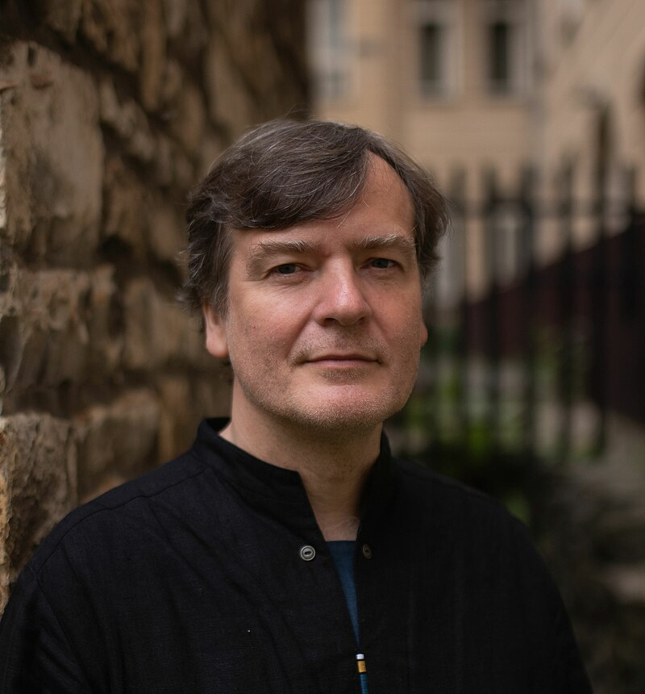

**Jaromír Typlt**

He spent his childhood in Nová Paka. He graduated from the Faculty of Arts at Charles University, majoring in philosophy and Czech language and literature. After completing his alternative civilian service at Fokus MYklub Liberec, an association for the care of the mentally ill—where he also initiated a number of exhibitions and publishing projects—he became the curator of the Small Exhibition Hall in Liberec in 2000, and from 2008 to 2010, he was the curator of the Gallery U Rytíře in Liberec.

He currently lives in Prague and Nová Paka.

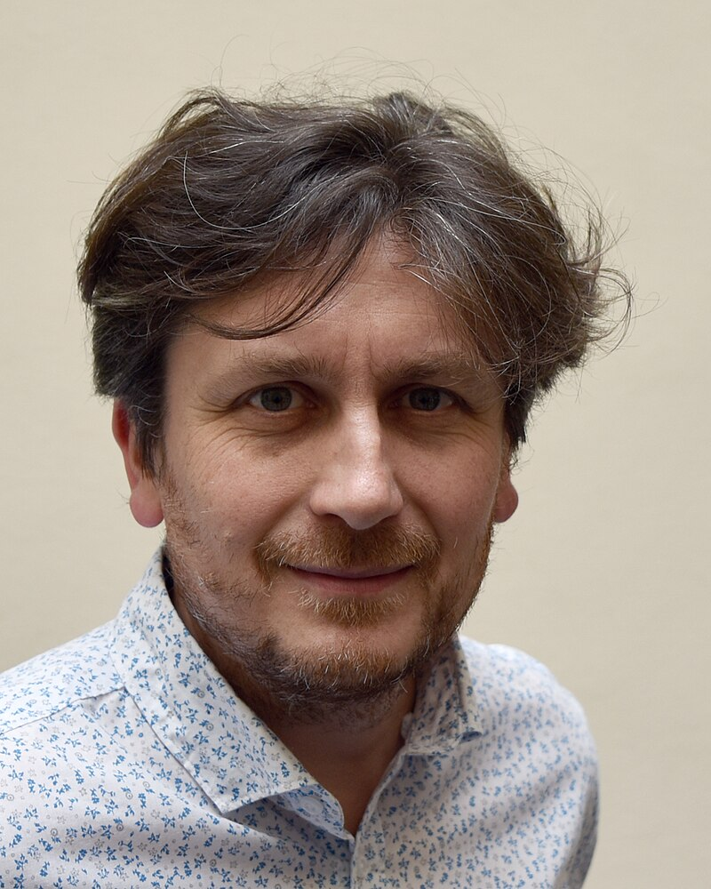

**Pavel Novotný**

He is a Czech poet, translator, Germanist, and educator. He works at the Department of German Language at the Faculty of Education of the Technical University in Liberec. He is the author of numerous poetry collections, such as Emergency Regulations, Tramvesty, and From the Inside. Together with Helena Skalická, he wrote the prose work And Then You Can Say Whatever You Want. He has created a number of radiophonic compositions for Czech Radio Vltava, including the composition Universe. As a literary scholar, he focuses on literary collage and montage, as well as on the field of so-called acoustic literature and experimental radio plays.